# LLM Generated Cypher Querying Performance

Model Used: gemini-2.0-flash

Query: Neo4j Cloud API

Main Libraries used: ChatGoogleGenerativeAI, langchain.tools, Neo4jGraph

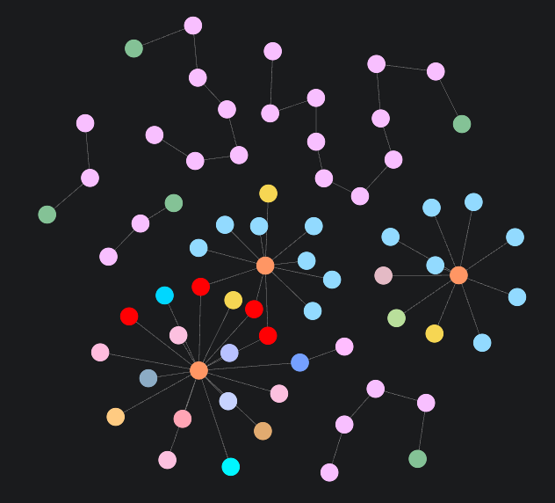

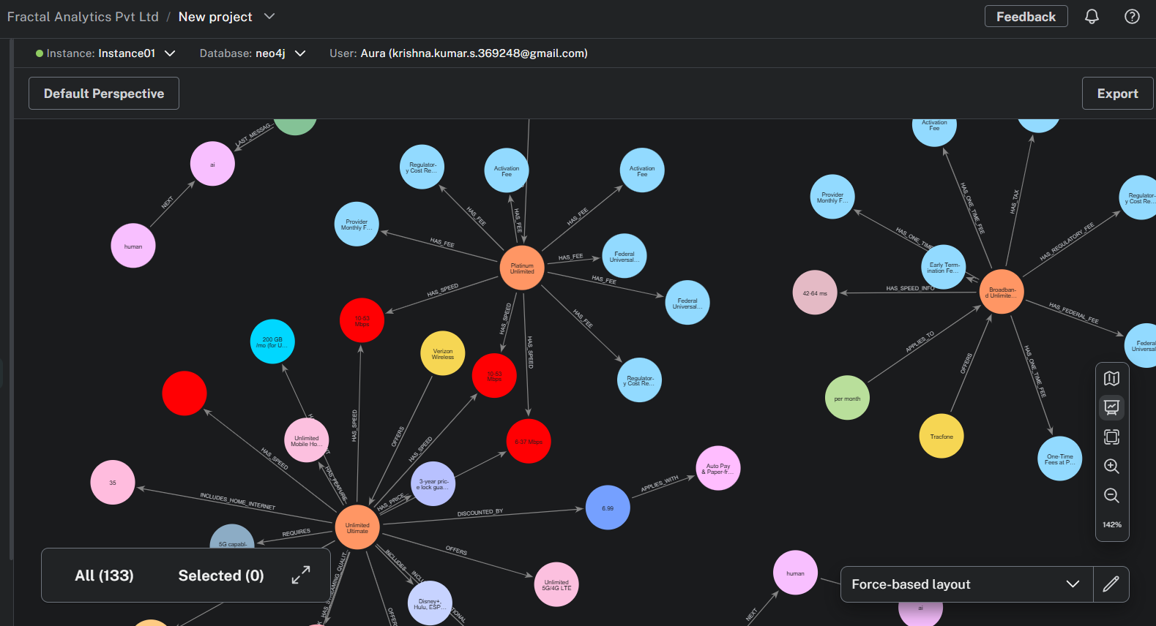

## Scenario 1

### Query:

plans with international features

### Response:

MATCH (p:Plan)-[:INCLUDES_INTERNATIONAL]->(i:InternationalFeature)

RETURN p

### Query results:

[{'p': {'name': 'Unlimited Ultimate'}}]

## Scenario 2

### Query:

plans with all kinds of speeds details

### Response:

MATCH (p:Plan)-[:HAS_SPEED]->(s:Speed)

RETURN p, s

### Query results:

[{'p': {'monthly_price': '$225.00 per line',

'monthly_price_notes': 'Introductory Offer: $60.00 per line for the first 3 months with Auto Pay',

'disclosure_title': 'Mobile Broadband Consumer Disclosure',

'discounts_and_bundles_link': 'Available discounts and pricing options for broadband service bundled with other services like video, phones, and wireless services, and use of your own equipment like modem or routers.',

'name': 'Platinum Unlimited',

'data_included': 'Unlimited',

'additional_data_charges': 'Varies by location'},

's': {'upload_speed': '10-53 Mbps',

'latency': '37-57 ms',

'download_speed': '195-634 Mbps',

'network_type': '5G Ultra Wideband'}},

{'p': {'monthly_price': '$225.00 per line',

'monthly_price_notes': 'Introductory Offer: $60.00 per line for the first 3 months with Auto Pay',

'disclosure_title': 'Mobile Broadband Consumer Disclosure',

'discounts_and_bundles_link': 'Available discounts and pricing options for broadband service bundled with other services like video, phones, and wireless services, and use of your own equipment like modem or routers.',

'name': 'Platinum Unlimited',

'data_included': 'Unlimited',

'additional_data_charges': 'Varies by location'},

's': {'upload_speed': '10-53 Mbps',

'latency': '37-57 ms',

'download_speed': '195-634 Mbps',

'network_type': '5G'}},

{'p': {'monthly_price': '$225.00 per line',

'monthly_price_notes': 'Introductory Offer: $60.00 per line for the first 3 months with Auto Pay',

'disclosure_title': 'Mobile Broadband Consumer Disclosure',

'discounts_and_bundles_link': 'Available discounts and pricing options for broadband service bundled with other services like video, phones, and wireless services, and use of your own equipment like modem or routers.',

'name': 'Platinum Unlimited',

'data_included': 'Unlimited',

'additional_data_charges': 'Varies by location'},

's': {'upload_speed': '6-37 Mbps',

'latency': '42-63 ms',

'download_speed': '34-149 Mbps',

'network_type': '4G LTE'}},

{'p': {'name': 'Unlimited Ultimate'},

's': {'value': 'Up to 6 Mbps (Mobile Hotspot)'}},

{'p': {'name': 'Unlimited Ultimate'},

's': {'upload_speed': '10-53 Mbps',

'latency': '37-57 ms',

'download_speed': '195-634 Mbps',

'network_type': '5G Ultra Wideband'}},

{'p': {'name': 'Unlimited Ultimate'},

's': {'upload_speed': '10-53 Mbps',

'latency': '37-57 ms',

'download_speed': '195-634 Mbps',

'network_type': '5G'}},

{'p': {'name': 'Unlimited Ultimate'},

's': {'upload_speed': '6-37 Mbps',

'latency': '42-63 ms',

'download_speed': '34-149 Mbps',

'network_type': '4G LTE'}}]

## Scenario 3

### Query:

plans pricing and all kinds of fees

### Response:

cypher

MATCH (p:Plan)

OPTIONAL MATCH (p)-[:HAS_PRICING]->(pricing:Pricing)

OPTIONAL MATCH (p)-[:HAS_FEE]->(fee:Fee)

OPTIONAL MATCH (p)-[:HAS_ONE_TIME_FEE]->(oneTimeFee:Fee)

OPTIONAL MATCH (p)-[:HAS_EARLY_TERMINATION_FEE]->(earlyTerminationFee:Fee)

OPTIONAL MATCH (p)-[:HAS_FEDERAL_FEE]->(federalFee:Fee)

OPTIONAL MATCH (p)-[:HAS_REGULATORY_FEE]->(regulatoryFee:Fee)

OPTIONAL MATCH (p)-[:HAS_TAX]->(tax:Fee)

RETURN p, pricing, fee, oneTimeFee, earlyTerminationFee, federalFee, regulatoryFee, tax

### Query results:

[{'p': {'monthly_price': '$40.00',

'disclosure_title': 'Broadband Consumer Label',

'name': 'Broadband Unlimited Talk and Text with 20GB of Data',

'data_included': '20 GB',

'additional_data_charges': 'Check terms and conditions'},

'pricing': None,

'fee': None,

'oneTimeFee': {'amount': 'Varies', 'name': 'One-Time Fees at Purchase'},

'earlyTerminationFee': {'amount': '$0.00', 'name': 'Early Termination Fee'},

'federalFee': {'amount': '$0.23',

'name': 'Federal Universal Service Fund (FUSF)'},

'regulatoryFee': {'amount': '$0.08', 'name': 'Regulatory Cost Recovery'},

'tax': {'amount': 'Varies by location', 'name': 'Government Taxes'}},

{'p': {'monthly_price': '$40.00',

'disclosure_title': 'Broadband Consumer Label',

'name': 'Broadband Unlimited Talk and Text with 20GB of Data',

'data_included': '20 GB',

'additional_data_charges': 'Check terms and conditions'},

'pricing': None,

'fee': None,

'oneTimeFee': {'amount': '$0.00', 'name': 'Activation Fee'},

'earlyTerminationFee': {'amount': '$0.00', 'name': 'Early Termination Fee'},

'federalFee': {'amount': '$0.23',

'name': 'Federal Universal Service Fund (FUSF)'},

'regulatoryFee': {'amount': '$0.08', 'name': 'Regulatory Cost Recovery'},

'tax': {'amount': 'Varies by location', 'name': 'Government Taxes'}},

{'p': {'monthly_price': '$40.00',

'disclosure_title': 'Broadband Consumer Label',

'name': 'Broadband Unlimited Talk and Text with 20GB of Data',

'data_included': '20 GB',

'additional_data_charges': 'Check terms and conditions'},

'pricing': None,

'fee': None,

'oneTimeFee': {'amount': '$0.00', 'name': 'Provider Monthly Fees'},

'earlyTerminationFee': {'amount': '$0.00', 'name': 'Early Termination Fee'},

'federalFee': {'amount': '$0.23',

'name': 'Federal Universal Service Fund (FUSF)'},

'regulatoryFee': {'amount': '$0.08', 'name': 'Regulatory Cost Recovery'},

'tax': {'amount': 'Varies by location', 'name': 'Government Taxes'}},

{'p': {'monthly_price': '$225.00 per line',

'monthly_price_notes': 'Introductory Offer: $60.00 per line for the first 3 months with Auto Pay',

'disclosure_title': 'Mobile Broadband Consumer Disclosure',

'discounts_and_bundles_link': 'Available discounts and pricing options for broadband service bundled with other services like video, phones, and wireless services, and use of your own equipment like modem or routers.',

'name': 'Platinum Unlimited',

'data_included': 'Unlimited',

'additional_data_charges': 'Varies by location'},

'pricing': None,

'fee': {'amount': '$0.00', 'name': 'Activation Fee', 'type': 'additional'},

'oneTimeFee': None,

'earlyTerminationFee': None,

'federalFee': None,

'regulatoryFee': None,

'tax': None},

{'p': {'monthly_price': '$225.00 per line',

'monthly_price_notes': 'Introductory Offer: $60.00 per line for the first 3 months with Auto Pay',

'disclosure_title': 'Mobile Broadband Consumer Disclosure',

'discounts_and_bundles_link': 'Available discounts and pricing options for broadband service bundled with other services like video, phones, and wireless services, and use of your own equipment like modem or routers.',

'name': 'Platinum Unlimited',

'data_included': 'Unlimited',

'additional_data_charges': 'Varies by location'},

'pricing': None,

'fee': {'amount': '$0.00',

'name': 'Provider Monthly Fees',

'type': 'additional'},

'oneTimeFee': None,

'earlyTerminationFee': None,

'federalFee': None,

'regulatoryFee': None,

'tax': None},

{'p': {'monthly_price': '$225.00 per line',

'monthly_price_notes': 'Introductory Offer: $60.00 per line for the first 3 months with Auto Pay',

'disclosure_title': 'Mobile Broadband Consumer Disclosure',

'discounts_and_bundles_link': 'Available discounts and pricing options for broadband service bundled with other services like video, phones, and wireless services, and use of your own equipment like modem or routers.',

'name': 'Platinum Unlimited',

'data_included': 'Unlimited',

'additional_data_charges': 'Varies by location'},

'pricing': None,

'fee': {'amount': '$0.26 - $0.37',

'name': 'Federal Universal Service Fund',

'type': 'additional'},

'oneTimeFee': None,

'earlyTerminationFee': None,

'federalFee': None,

'regulatoryFee': None,

'tax': None},

{'p': {'monthly_price': '$225.00 per line',

'monthly_price_notes': 'Introductory Offer: $60.00 per line for the first 3 months with Auto Pay',

'disclosure_title': 'Mobile Broadband Consumer Disclosure',

'discounts_and_bundles_link': 'Available discounts and pricing options for broadband service bundled with other services like video, phones, and wireless services, and use of your own equipment like modem or routers.',

'name': 'Platinum Unlimited',

'data_included': 'Unlimited',

'additional_data_charges': 'Varies by location'},

'pricing': None,

'fee': {'amount': '$0.09 - $0.13',

'name': 'Regulatory Cost Recovery',

'type': 'additional'},

'oneTimeFee': None,

'earlyTerminationFee': None,

'federalFee': None,

'regulatoryFee': None,

'tax': None},

{'p': {'monthly_price': '$225.00 per line',

'monthly_price_notes': 'Introductory Offer: $60.00 per line for the first 3 months with Auto Pay',

'disclosure_title': 'Mobile Broadband Consumer Disclosure',

'discounts_and_bundles_link': 'Available discounts and pricing options for broadband service bundled with other services like video, phones, and wireless services, and use of your own equipment like modem or routers.',

'name': 'Platinum Unlimited',

'data_included': 'Unlimited',

'additional_data_charges': 'Varies by location'},

'pricing': None,

'fee': {'amount': '$0.00', 'name': 'Activation Fee', 'type': 'one_time'},

'oneTimeFee': None,

'earlyTerminationFee': None,

'federalFee': None,

'regulatoryFee': None,

'tax': None},

{'p': {'monthly_price': '$225.00 per line',

'monthly_price_notes': 'Introductory Offer: $60.00 per line for the first 3 months with Auto Pay',

'disclosure_title': 'Mobile Broadband Consumer Disclosure',

'discounts_and_bundles_link': 'Available discounts and pricing options for broadband service bundled with other services like video, phones, and wireless services, and use of your own equipment like modem or routers.',

'name': 'Platinum Unlimited',

'data_included': 'Unlimited',

'additional_data_charges': 'Varies by location'},

'pricing': None,

'fee': {'amount': '$0.26 - $0.37',

'name': 'Federal Universal Service Fund',

'type': 'one_time'},

'oneTimeFee': None,

'earlyTerminationFee': None,

'federalFee': None,

'regulatoryFee': None,

'tax': None},

{'p': {'monthly_price': '$225.00 per line',

'monthly_price_notes': 'Introductory Offer: $60.00 per line for the first 3 months with Auto Pay',

'disclosure_title': 'Mobile Broadband Consumer Disclosure',

'discounts_and_bundles_link': 'Available discounts and pricing options for broadband service bundled with other services like video, phones, and wireless services, and use of your own equipment like modem or routers.',

'name': 'Platinum Unlimited',

'data_included': 'Unlimited',

'additional_data_charges': 'Varies by location'},

'pricing': None,

'fee': {'amount': '$0.09 - $0.13',

'name': 'Regulatory Cost Recovery',

'type': 'one_time'},

'oneTimeFee': None,

'earlyTerminationFee': None,

'federalFee': None,

'regulatoryFee': None,

'tax': None},

{'p': {'name': 'Unlimited Ultimate'},

'pricing': {'amount': 55.0, 'unit': '/line'},

'fee': None,

'oneTimeFee': None,

'earlyTerminationFee': None,

'federalFee': None,

'regulatoryFee': None,

'tax': None}]